Where are skin cancers most common? The commonest sites are on the most sun exposed parts of the body. Although it is uncommon, you can even get skin cancers where there is no sun exposure e.g. between the toes.

How important are Sunscreen and a hat? Sun protection is essential if skin cancer incidence is to be reduced. Sun protection will have the greatest impact if achieved as early as possible in life.

Is it worth using sunscreen when you’re older? Sun protection will have a positive
impact later in life, especially in those who had high childhood exposure to solar radiation. (3)

SKIN CLINIC STAFF
Dr Tim Phillips is a Fellow of the Royal New Zealand College of General Practitioners. He has been running skin clinics for 20 years and has used this experience to develop the system that is being used in Mapua.

Tim does not do cosmetic surgery however he does do cosmetic procedures for patients with strong medical grounds for these, especially when they don’t qualify for care in the public system. One example of this is doing an eyelid lift for someone who is having difficulty seeing because of low hanging lids, or removal of unsightly skin lesions that cause psychological distress.

Fleur and Sarah are our general medical and surgical nurses. They manage the mapping system that lets us track and respond to changes on your skin. They also look after the clinics where we use topical chemotherapy to manage precancerous skin lesions to avoid surgery.

WHAT HAPPENS WHEN YOU ARRIVE FOR YOUR SKIN CHECK
- You will have a private changing space
- As a general rule it’s OK to leave undergarments on but NOT socks
- If you are female it is your own choice as to whether or not you leave your bra on
- You will be discretely covered with sheets during the examination
- If you are female there will be a female nurse chaperoning
- If you are male and would like a chaperone please let reception know

THINGS THAT HELP US
- Do not wear makeup
- Draw a circle around any spots you or your family are worried about (but not more than 3 because we’ll be checking all your spots anyhow)
- No need to draw on your face you can show us any spots that worry you there on the day

WHAT WILL HAPPEN?
- We will ask you a series of questions to calculate your UV exposure, melanoma risk and the things that you do to reduce your risk and this will help us know how often to check your skin
- You will lie down and we will systemically check every bit of skin; not genitalia, unless you have specific concern in which case let us know
- When we check your face we will ask you to close your eyes because the light is very bright
- If you still have hair and you require a detailed scalp check this is a separate 15 minute appointment for scalp check. Most people won’t need this
- If you do have a spot that you can find in your scalp then we are happy to check this during a normal skin check, we just don’t have the time to go through all your hair. Remember to ask your hairdresser to let you know if there are any spots that need checking.

THE EQUIPMENT
A dermatoscope is a special magnifying device that sees through skin.
The skin has a shiny surface called the stratum corneum. This reflects light so that skin lesions often look uniform. The dermatoscope looks through this layer so that we can see the patterns of pigment, blood vessels and other features that help to make a more accurate diagnosis.

The dermatoscope is for confirming a spot is benign. If the spot has any suspicious features it will be removed and sent to the lab where it goes through a series of preparations and special stains so that the histolpathologist (skin microscope specialist) can make an exact diagnosis.

The stages of checking a spot

What you see
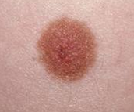
What the dermatoscope sees
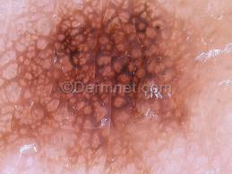
What the lab sees
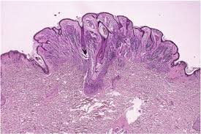

PRICING
- The fee for 30 minute dermatoscopic full skin check is $110 (enrolled patients)
- The fee per 15 minutes of operating time is $100; this covers costs of subspecialty doctor, nurse, room rental and equipment
- Unfortunately surgical equipment can be very expensive. A single dissolving suture can cost, for example, up to $50.
- There is an additional charge of $20-50 for sutures and dressings depending on what is used.
- One follow up nurse check and suture removal is free.
- There is NO markup on equipment used
- All lab processing is free of charge.

REFERENCES
  - McKenzie R, Connor B; Bodeker G Increased Summertime UV Radiation in New Zealand in Response to Ozone Loss National Institute of Water and Atmospheric Research, NIWA Lauder, PB 50061 Omakau, Central Otago, New Zealand.
  - Gruijl F.; Skin Cancer and solar UV radiation European Journal of Cancer ; Vol 35, issue 14; 1999, Pages 2003-3009
  - Armstrong B; Kricker A; The epidemiology of UV induced skin cancer ; J Photochem & Photobiology Vol 63 Issues 1-3; 2001, Pages 8-1

Last revised: 11 January 2017. This document is the intellectual property of Mapua Health Centre
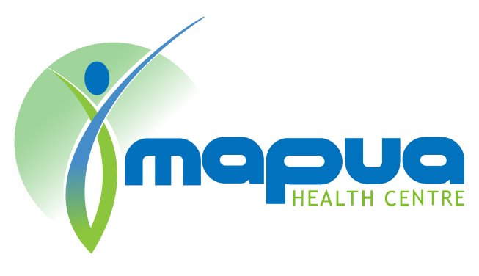
MAPUA HEALTH CENTRE
Skin Check Information
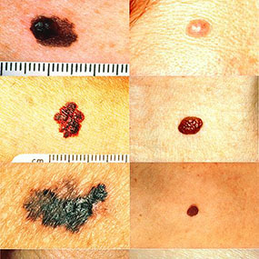

New Zealand sunlight is amongst the most dangerous in the world; the trouble is that New Zealand sunlight has one of the highest levels of UV in the world, especially the type that can cause DNA-damage. (1)

Does sunlight cause skin cancer? Sun is a carcinogen and this means it can cause cancer. Ultraviolet (UV) radiation in sunlight is the most prominent carcinogen in our natural environment. (2)

Who is most at risk? There is strong evidence that the main types of skin cancer are caused by sun exposure. More so in fair skinned, sun-sensitive people; skin cancer risk increases with sun exposure.

